OPERATION AND MAINTENANCE INSTRUCTION MANUAL
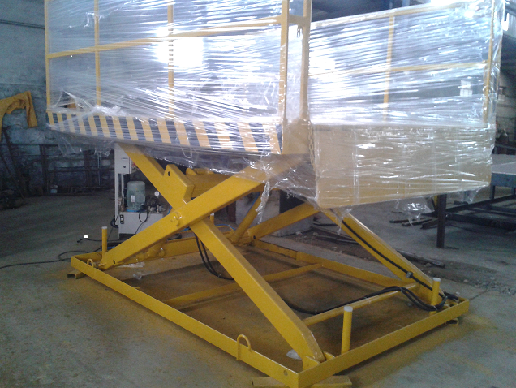
ELECTRO-HYDRAULIC SCISSOR LIFT TABLE
NAME OF THE CUSTOMER :.NIHVA TECHNOLOGIES PVT LTD.

GAT NO. 1559/1560, DEHU - ALANDI ROAD,
SHELAR VASTI, CHIKHALI, PUNE - 412 114.
PHONE NO. - 020 – 66346500.
E-mail :- contactus@technovisionengrs.com
13.06.2015

TABLE OF CONTENTS

- GENERAL INFORMATION
  - Introduction
  - Construction of equipment
  - Technical Specifications
  - General Assembly Drawings
  - Use of the equipment
  - Special features
- OPERATION OF THE EQUIPMENT
  - Unloading and transporting
  - Sequence of operation
  - Owners Responsibility
- SAFETY
  - Operational safety
  - Notice Items
  - Safety Warnings
- MAINTENANCE
  - Maintenance Schedule
  - Trouble Shooting
  - Reference Drawings
  - Certificates and Reference
  - Warranty Clause

- GENERAL INFORMATION
  - Introduction
Please read and understand this manual carefully before Installing, starting, operating, repairing or maintaining the Electro-Hydraulic Scissor Lift (Pit Mounted). This equipment is designed by Technovision Engineers Pvt Ltd (TEPL) to provide safer operation to the workers during loading and unloading of the material. The Electro-Hydraulic Scissor Lift when properly operated provides safe, secure and hassle free working environment during loading and unloading of the material within the reach of the equipment. The equipment can be operated from the main control panel mounted on the ground to the nearest place of the equipment as well as from the separate pendant given on the lifting platform. This manual provides information regarding the installation, use, operation, safety, repair and maintenance of the equipment. The operator and maintenance staff should be trained before using of this equipment. Please contact TEPL for any further query, clarification or more information required. Buyer is requested to preserve this manual in good condition throughout the service life of the Equipment/Machine. The operator and all persons who may come into contact of this equipment should read it regularly and have access to it at all times. Failure to comply with the safety instructions and warnings in this manual may result in serious injury to the operator or other persons in the vicinity of the machine. The equipment is usable within the temperature range from -5°C to 45°C. Authorized personnel are staff who are permitted to operate Electro-Hydraulic Scissor Lift Table according to local statutory requirements and are appointed within the company to do this.

The equipment is designed with UDL capacity 2000kgs, Platform Size 2200x1300mm, lift height 1200mm (from pit). Input power supply is required 440VAC, 3Phase, 50Hz.
  - Construction of the equipment
The equipment consists of following components;
- Lifting platform (Top Platform): Top platform is constructed with high quality robust steel with required reinforcement with safety railing and manually operated foldable flap. Top platform is constructed with suitable MS checkered plate.
- Scissor Arms: Scissor arms are constructed with high quality robust steel with suitable reinforcement to the pivot joints. Self-lubricated bushes are used to minimize the maintenance. All the pins and rods are hardened with suitable grade material. Scissor arms are lifted with the help of 2nos of hydraulic cylinders connected to the scissor arms and bottom frame structure. Sliding rollers are made of special material with ball bearings inside with suitable runner plate in its path. Scissor arms are the most important part of the equipment which connects the bottom frame and the top frame of the equipment.
- Bottom frame: Top platform is constructed with high quality robust steel with required reinforcement with provision for the anchoring, lifting hooks and rest pads.
- Hydraulic Power Pack (AC Powered): AC Power pack consists of electric motor, Gear Pump, Filler breather assembly, suction strainer, Pressure relief valve, Puppet Type Valve, Oil Level Indicator, Pressure gauge etc.
- Control Panel: Electrical control panel consists of all the reputed brand accessories like Contactor/Over Load Relays MCB/MPCB/Indicators Push Buttons/Limit Switches etc.

  - Technical Specifications
- Name of the equipment : Electro-Hydraulic Scissor Lift Table (Pit Mounted).
- UDL Capacity : 2000kgs
- Platform Size : 2200mm x1300mm (L x W)
- Lift Height : 1200mm (From pit)
- Self-weight of the equipment : 650kgs Approximately
- Input Power Supply : 440VAC, 3Ph, 50Hz
- Lifting and lowering speed : 50-60mm/sec
- Product Sr. Nr. : EHSL-035
- Year Of Manufacturing : June 2015
  - General Assembly Drawing

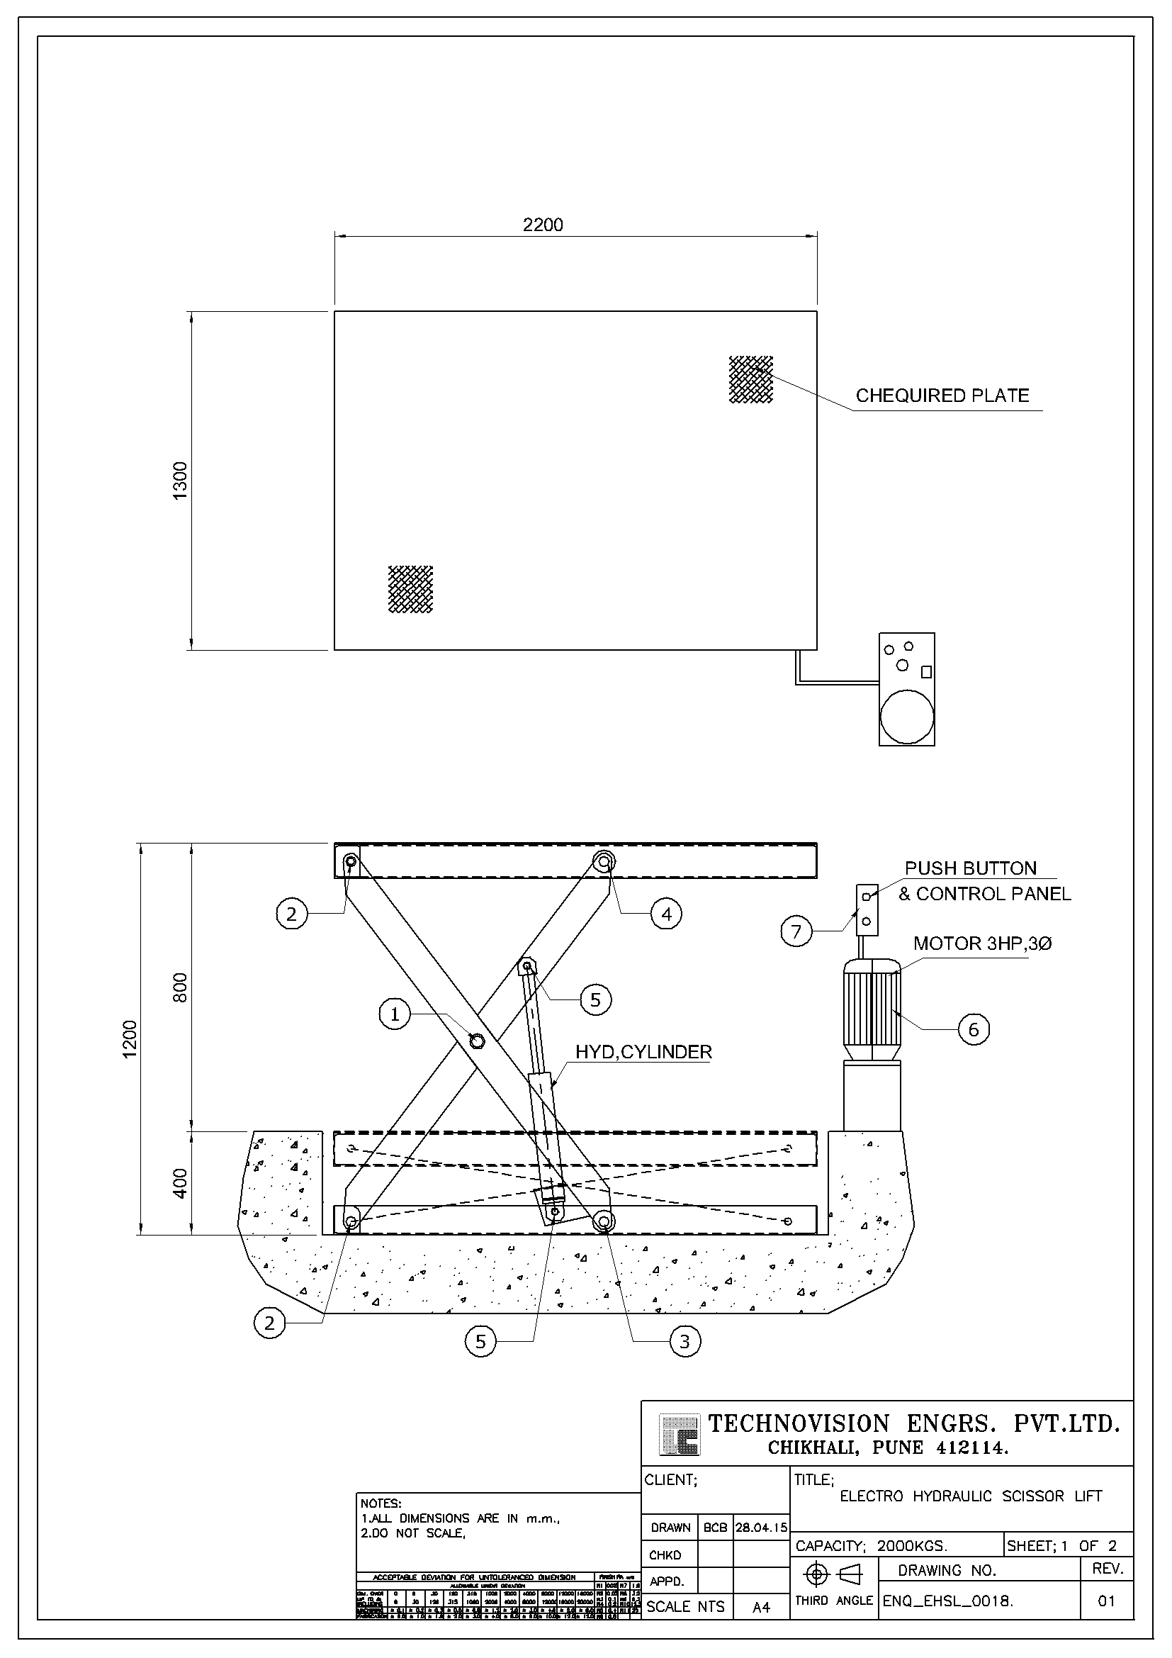

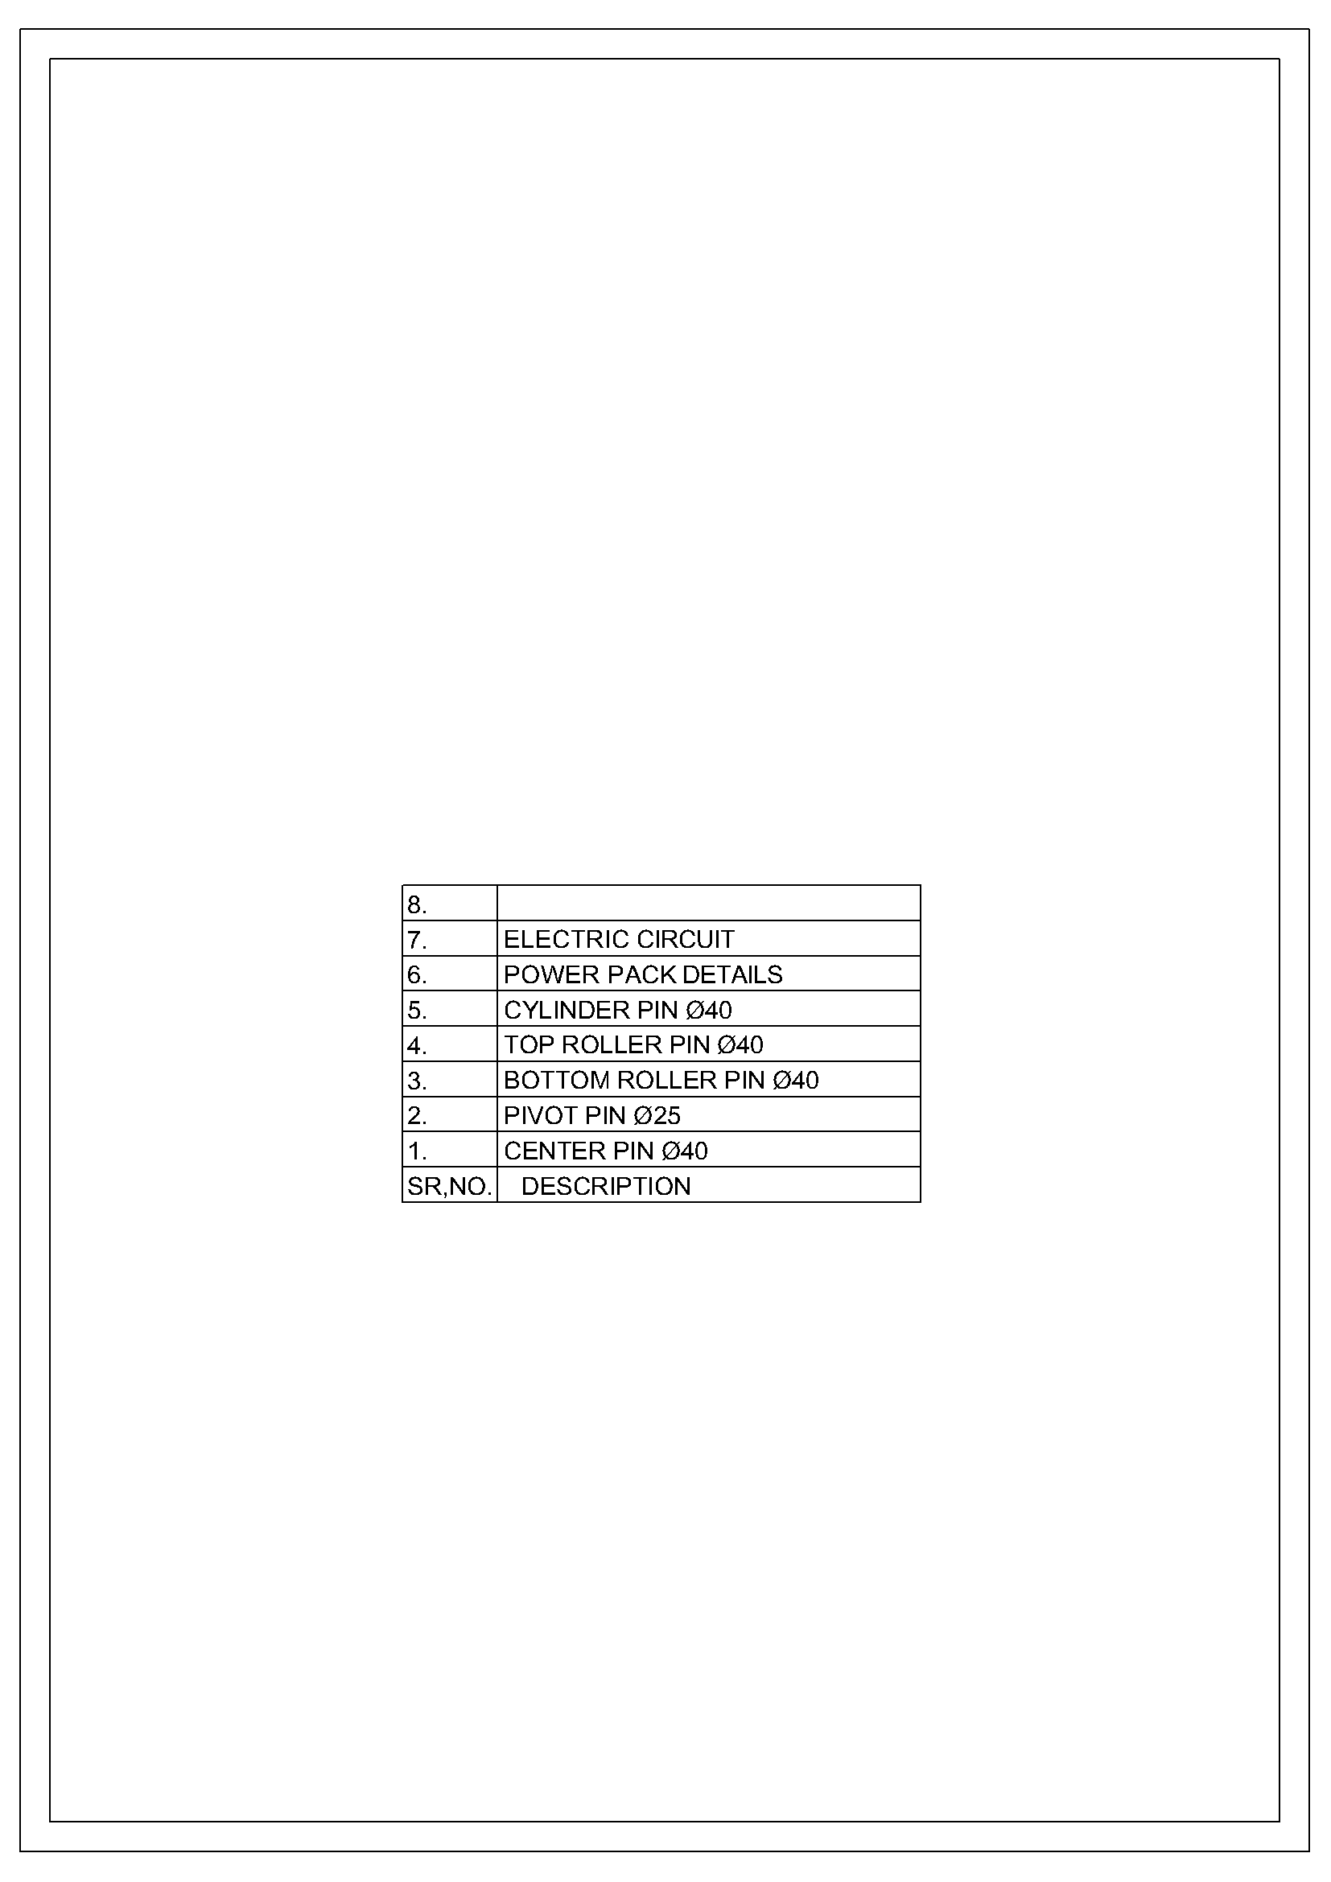

  - Use of the Equipment
Electro-Hydraulic Scissor Lift Table (Pit Mounted) is designed to enable operator to bridge the height difference between the shop floor and the vehicle platform at the loading and unloading bay. The equipment also find its application for loading and unloading of the material from one floor to another floor, from ground to 1st, 2nd floor depending upon the lift height, to maintain the working height at the assembly line etc. The equipment can be installed into the pit as well as on the shop floor depending upon the application of the equipment. The equipment can be operated from the control panel located at the ground near the equipment and from the separate pendent provided on the platform. The equipment is to be used within the premises of the company. This equipment helps to enhance the safety, efficiency and confidence of the operator and also reduces the valuable time required for completion the overhead works.

  - Special Features
- Equipment is designed with high strength robust material
- Safety protection given to arrest the sudden fall because of the rupture of hydraulic hoses.
- Self-lubricated bushes are provided at every pivot joint of the scissor

- OPERATION OF THE EQUIPMENT
  - Unloading and Transportation of the equipment
- The equipment is to be unloaded from the vehicle with utmost care with the help of EOT Crane or Hydra or Forklift Truck etc. with suitable lifting capacity. The vehicle should be engaged with brake/gear to pervert its movement while unloading of the equipment.
- The Industrial lifting belts of the suitable capacity to be used. Prior use inspection of the lifting belts must be done.
- The lifting belt hooks are provided for the lifting of the equipment. Lifting belts are to be engaged in crossway to the lifting hooks, please put proper packing between the belt and equipment body wherever it touch to the equipment to avoid any damage to the equipment while unloading.
- Please ensure that the load is balance centrally and ensure that the safety railing, top frame and other related parts of the equipment should not damage.
- Once it is balanced, lift the equipment carefully, remove the vehicle and keep the equipment on the floor/on the palletize structure.
- Once the equipment is kept on the floor, remove the lifting belts and move the equipment with the help of Forklift Truck to the desired location.
- The equipment can also be transported from one factory to another by loading into the suitable transport vehicle with due care as explained above.
  - Sequence of operation
- Read and understand the safety instructions given in the Operation and Maintenance manual regarding operation, maintenance and its use etc.
- The equipment must be used by the trained and specified person only. Untrained person and unauthorized persons are strictly prohibited to use the equipment.
- Before use the equipment is to be installed into the civil pit or on the shop floor with proper anchoring with the ground floor. Equipment has to be leveled and flushed to the ground during installation work.
- Connect to the input power supply of 440VAC to the nearest power supply available at the factory. Switch on the main power supply.
- Ensure the equipment checked as per the routine check points.
- Load the material on the platform, it should be Unique Distributed Load on the platform. Platform rated capacity indicates UDL capacity.
- Lift the equipment Up/Down with the help of the controls provided on the control panel at the bottom frame at ground.
- Lift the platform to the suitable height so that it should match to the vehicle platform. Put the flap on the vehicle to bridge the gap between equipment platform and the vehicle platform.
- Move the material safely into the vehicle, fold the flap and take down the equipment to its home conditions.
- Now the equipment is ready for next cycle, repeat all the above steps every time.
- Disconnect the electrical supply after use of the equipment.
- Clean the equipment after use and also keep clean surrounding area of the equipment.

  - Owner’s Responsibility
- The owner should recognize an inherent danger during operation of the equipment. The owner therefore, shall train and instruct the operators in the safe use of the equipment in accordance to the information provided below.
- The equipment should be perfectly leveled during installation of the equipment.
- Nameplates, cautions, instructions, and posted warnings shall not be obscured from the view of operating or maintenance personnel for whom such warnings are intended.
- Manufacturer’s recommended periodic maintenance and inspection procedures in effect at date of shipment shall be followed, and written records of the performance of these procedures should be kept.
- The equipment that is structurally damaged shall be removed from service, inspected by a manufacturer’s authorized representative, and repaired as needed before being placed back in use.
- The manufacturer shall make available replacement nameplates, caution/instruction labels, and operating/maintenance manuals upon request of the owner. The owner shall see that all nameplates, caution/instruction markings or labels are in place and legible, and that the appropriate operating/maintenance manuals are provided to users.
- Modifications or alteration to this equipment is strictly prohibited. If at all it is necessary shall be made only with written permission of the original manufacturer. These changes shall also satisfy all safety recommendations of the original equipment manufacturer for the particular application of this equipment.
- In order to be entitled to the benefits of the standard product warranty, the said equipment must have been properly installed, maintained and operated within its rated capacities and/or specific design parameters, and not otherwise abused.
- It is first, foremost and most important responsibility of the owner to comply all the safety precautions while using this equipment

- SAFETY
While working with the Electro-Hydraulic Scissor Lift Platform (pit mounted) the person who is responsible for supervising the operation environment should take the necessary organizational measures to guarantee the employees' health and safety as required by local legislation.

  - Operational Safety Precautions
The following safety precautions to be taken while using High Raised Electro-Hydraulic Scissor Lift Platform;

- Overloading is prohibited. Overloaded maximum 10% is allowed only in case of emergency.
- The equipment rated with UDL capacity so try to distribute the load equally on the platform.
- People are strictly prohibited to work on the table without safety guard devices like safety shoes or other required safety elements based on the working environment.
- If the working table is not lifting or lowering or there is any abnormal noise, the operator should stop any action immediately for checking in order not to cause serious damage to the Table. (See troubleshooting)
- Do not use the equipment in such a way in which it will damage. Damage to the equipment will ultimately cause for an accident and loss.

3.2 Notice Items
1. Read the manual book carefully before using the equipment, to know the performance and use of the equipment. Only authorized and trained operators are allowed to use the equipment.
2. Do not overload, use within the rated load, overload will damage to the equipment, people and goods;
3. The electric control panel of the equipment must have the proper earthing which can prevent the accident of electric leakage;
5. Please note that the equipment should not be kept in lifted conditions if it is not in use.
6. Please use the mechanical stoppers provided along with the equipment whenever you need to carry out any repair and maintenance work. This will prevent the falling of the platform and ensure the safety during repair and maintenance.
7. Strictly operate according to the “Notice items” otherwise it will cause damage to the people, vehicles and goods.

3.3 Safety Warnings
- Do not overload the equipment than the rated capacity. 10% overload allowed only in an emergency.

- Keep your body parts away from pinching pints. Be away from the moving parts.

- This equipment should not be operated or serviced except by trained personnel
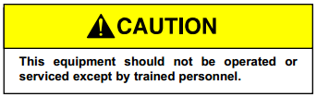

- Do not work underneath of this equipment unless it is locked mechanically

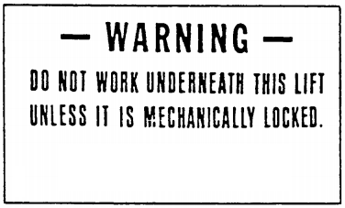

- Do not remove the guard rails, it is for your safety



- Do not try to shake the equipment when it is lifted condition, it may cause an accidents

- The platform can be taken down manually by release of hydraulic pressure in case of emergency
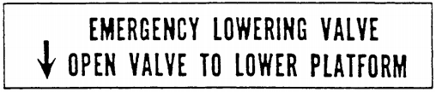

- It is unlawful to use the equipment within 10 feet of high voltage lines.


- Do not operate the equipment while under the influence of alcohol or drugs
- Do not leave equipment in lifted condition

- MAINTENANCE
4.1. Maintenance Schedule
Daily Maintenance
- Remove debris and other un-necessary material around the equipment, keep the area around neat & clean. Be sure the hinge section of the lip and the platform is clean.
- Clean the equipment for any dirt, dust etc.
- Check unit for proper operation and for any abnormal noise.

90 Days
- Perform all Daily Maintenance.
- Lubricate the unit with the proper lubricants.
- Inspect structure, hinge pins, cotter pins for abnormal wear.
- Check hydraulic fluid level in tank. Add fluid if necessary. Use only standard hydraulic fluids defined for the purpose. The correct fluid level is indicated on level indicator mounted on the tank.
- Inspect all conduit, boxes and electrical connections for damage. If control box has evidence of condensation;
- Inspect conduit. Conduit should be routed to enter through the bottom or side of the enclosure. A drip provision may be needed if the conduit is filling with water.
- Check all the nuts and bolts for proper tightening.
- Check and tighten all the electrical connections

180 Days
- Perform all Daily and 90 Days Maintenance.

360 Days
- Perform Daily, 90-Day and 180-Day Maintenance.

4.2 Trouble Shooting
Problem | Cause | Reason
- Equipment does not operate | - Improper/No input power supply  - Overload relay tripped  - Loose wire connection  - Wrong motor direction | - Check the main power supply, fuses etc.  - Reset overload relay, check for any overload  - Check all the electric connections are tightened properly, verify push button functioning properly  - Check motor direction, correct it.
- Operation is slow | - Low hydraulic oil level  - Low input power voltage  - Hydraulic oil leakage  - Hydraulic system jammed  - Spools in the hydraulic valves are not operation properly  - Faulty motor or hydraulic pump | - Check Hydraulic oil level. Update if needed  - Check input power voltage and correct  - Check for any leakage of hydraulic oil and rectify  - Check for any obstruction in the hydraulic system  - Check proper voltage/magnetization to the solenoid coil, verify the wiring, replace the solenoid coil  - Check and rectify/replace
- Operation stops suddenly during the operation cycle | - Main power failed  - Overload relay tripped  - Loose wire connection  - Hydraulic system failure | - Check the input power supply, check fuses  - Reset overload relay, check for any overload  - Check all the electric connections are tightened properly, verify push button functioning properly  - Check hydraulic pump, hoses, valves, fittings for leakage, rectify if any.
- Platform down too slow | - Improper functioning of Solenoid Valve | - Check for the proper functioning of solenoid valve
- Platform down too fast, does not stop at any position | - Faulty or in-correct oil flow  - Spools in the hydraulic valves are not operation properly  - Manual hydraulic pressure release valve is open | - Check flow-control valve, replace if needed  - Check proper voltage/magnetization to the solenoid coil, verify the wiring, replace the solenoid coil  - Check the manual hydraulic release on the hydraulic power pack
- Platform Raise when “PLATFORM DOWN” button is pressed | - Solenoid valve not functioning properly  - Push button not functioning properly | - Please check solenoid coils magnetized/operated properly, check solenoid valve spool operation  - Check for the electrical contacts
- Platform lower when “LIP UP” button is pressed | - Solenoid valve not functioning properly  - Push button not functioning properly | - Please check solenoid coils magnetized/operated properly, check solenoid valve spool operation  - Check for the electrical contacts
- Main motor does not run even if the power to the solenoid coil | - Overload relay tripped | - Reset the overload relay and check for any obstruction in the operation.
- Any other problem |  | - Contact the manufacturer

4.3 Reference Drawings, Photographs

4.3.1 Hydraulic Circuit Diagram

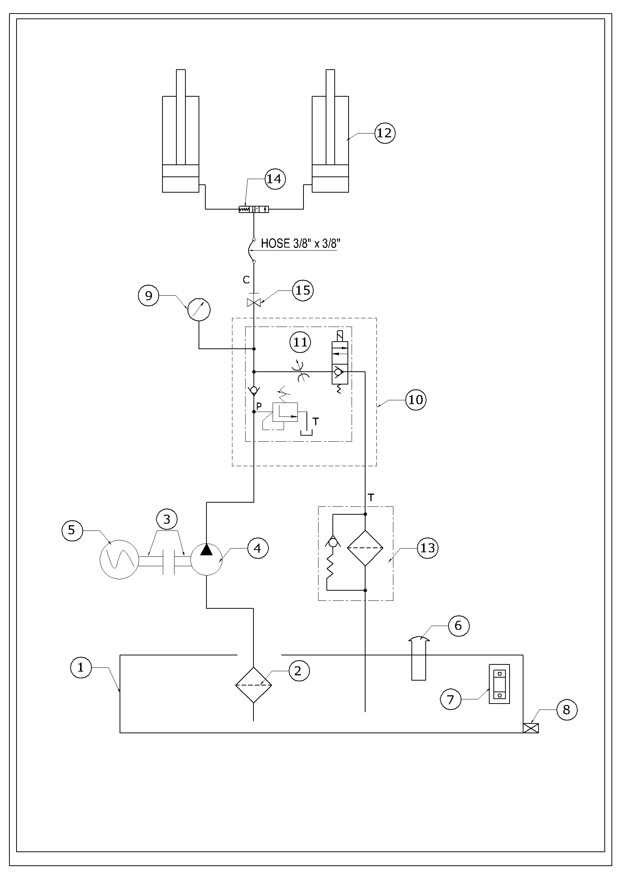

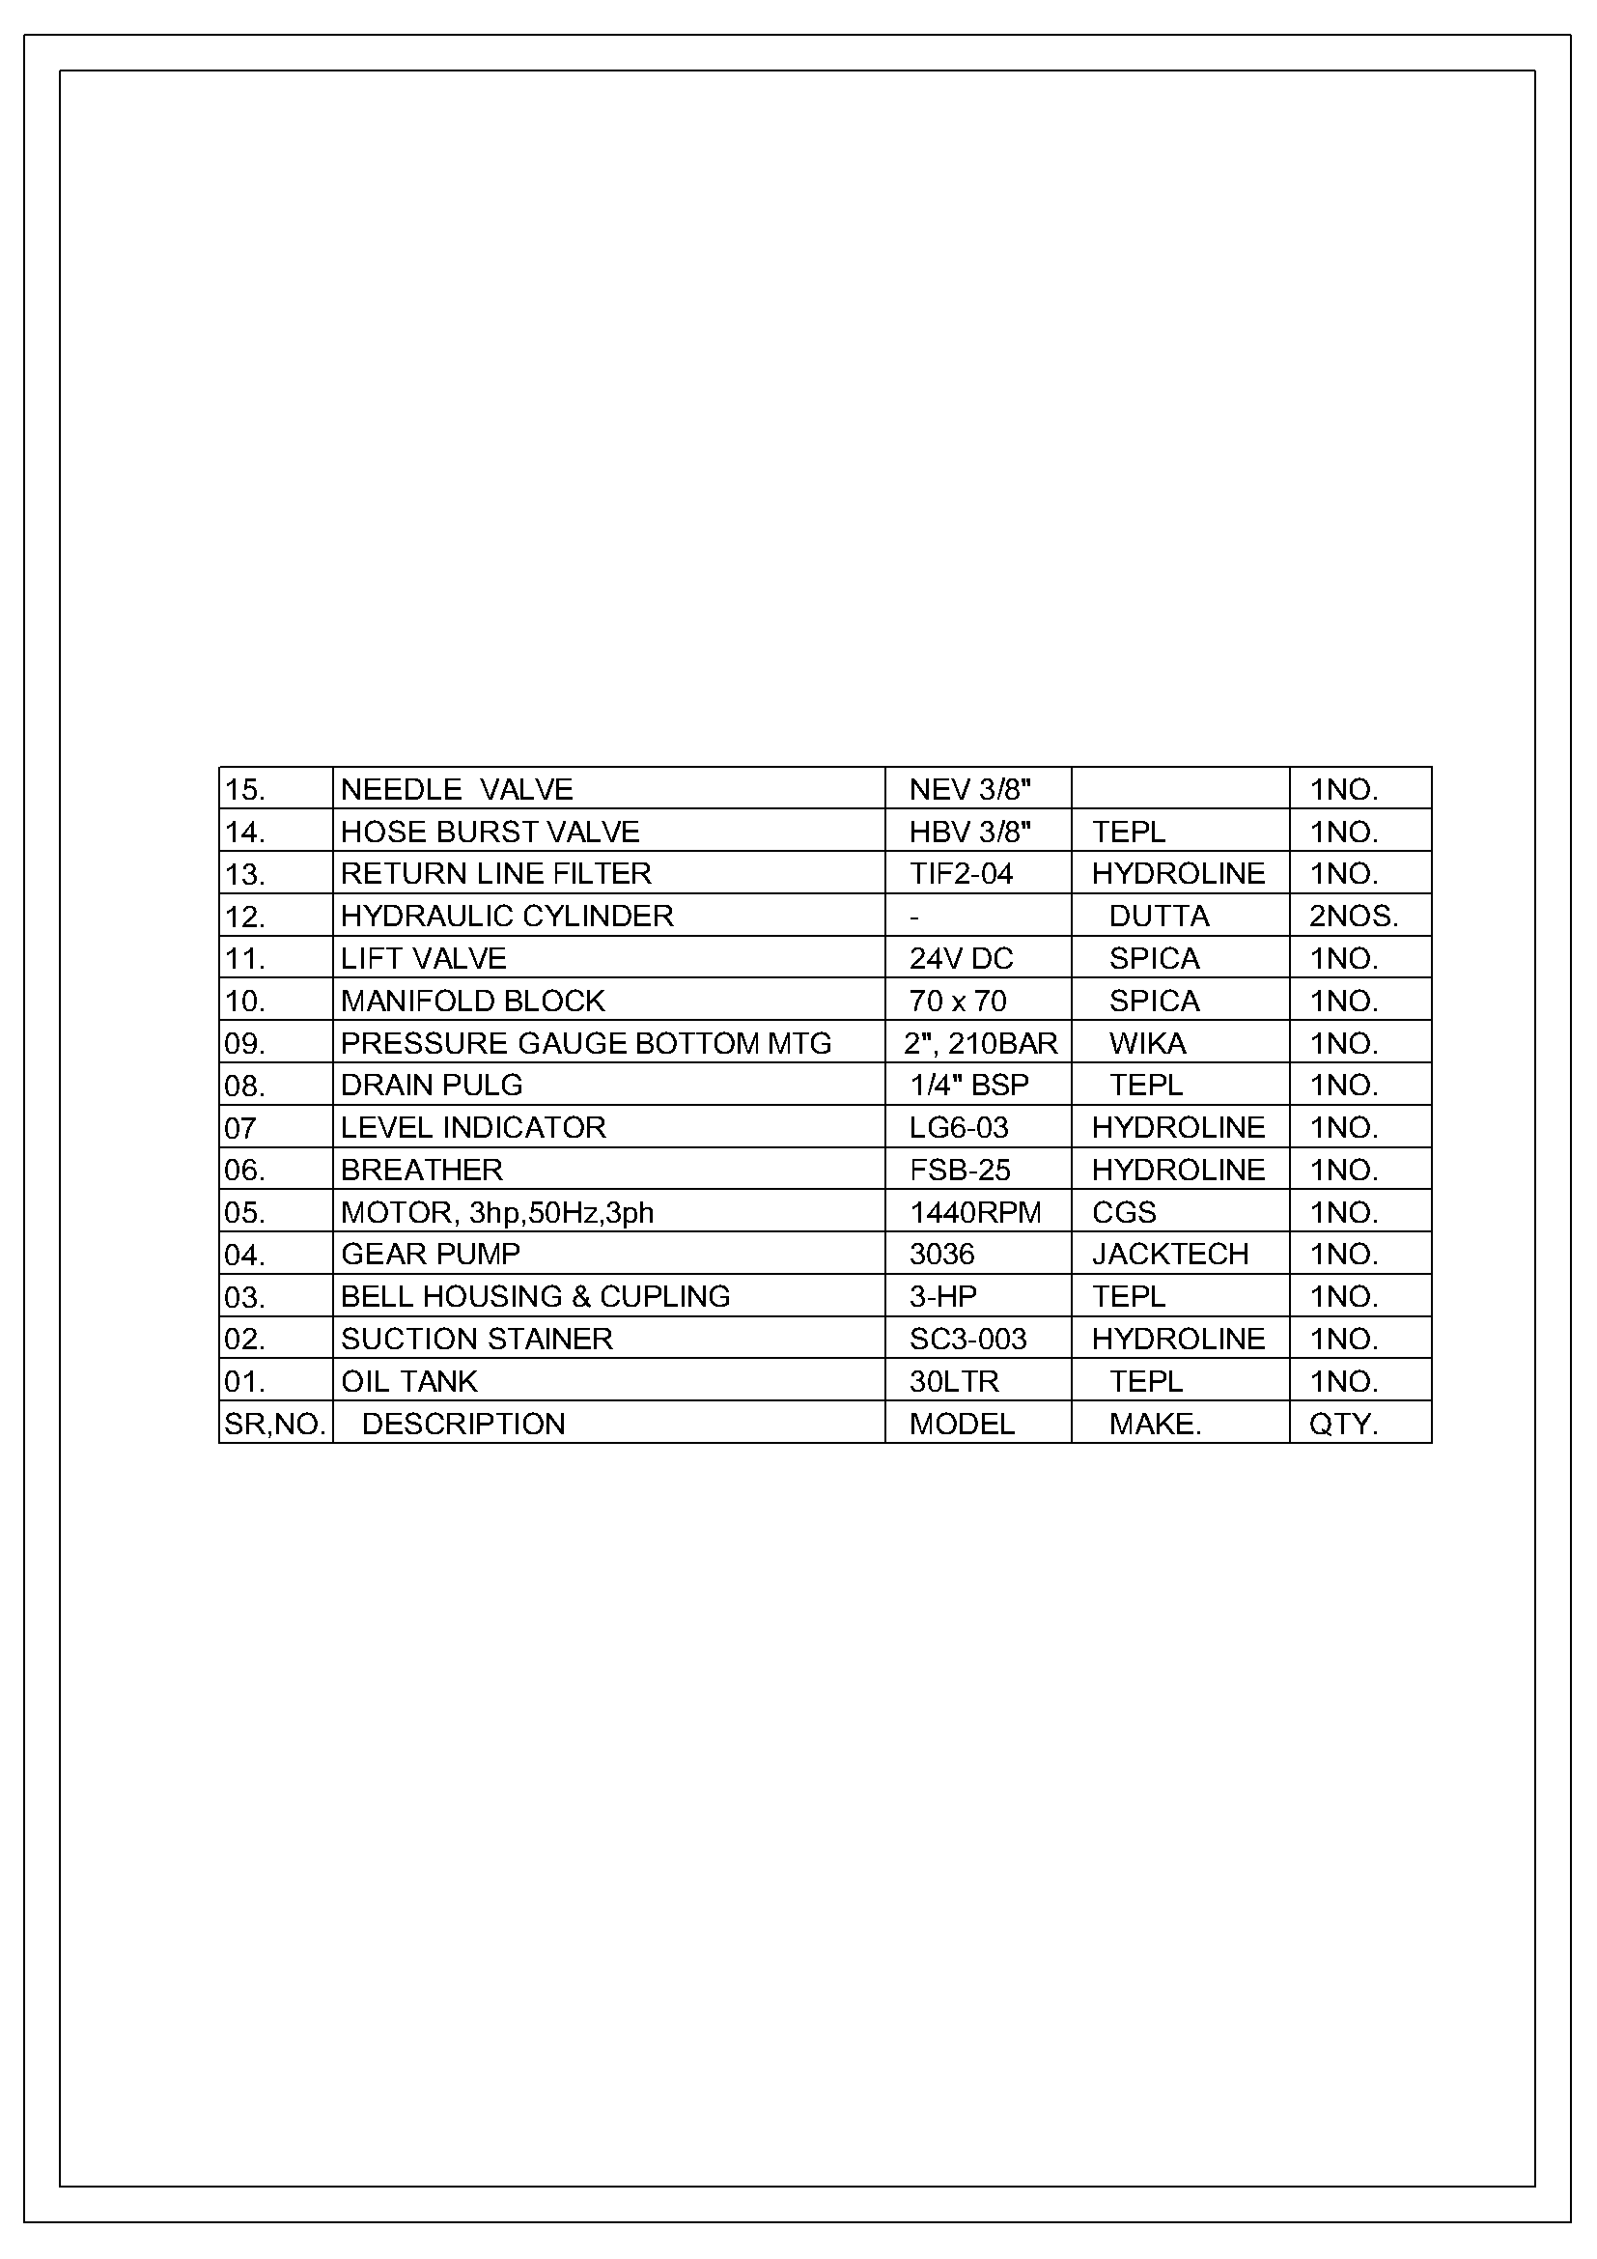

4.3.2 Electrical Circuit Diagram
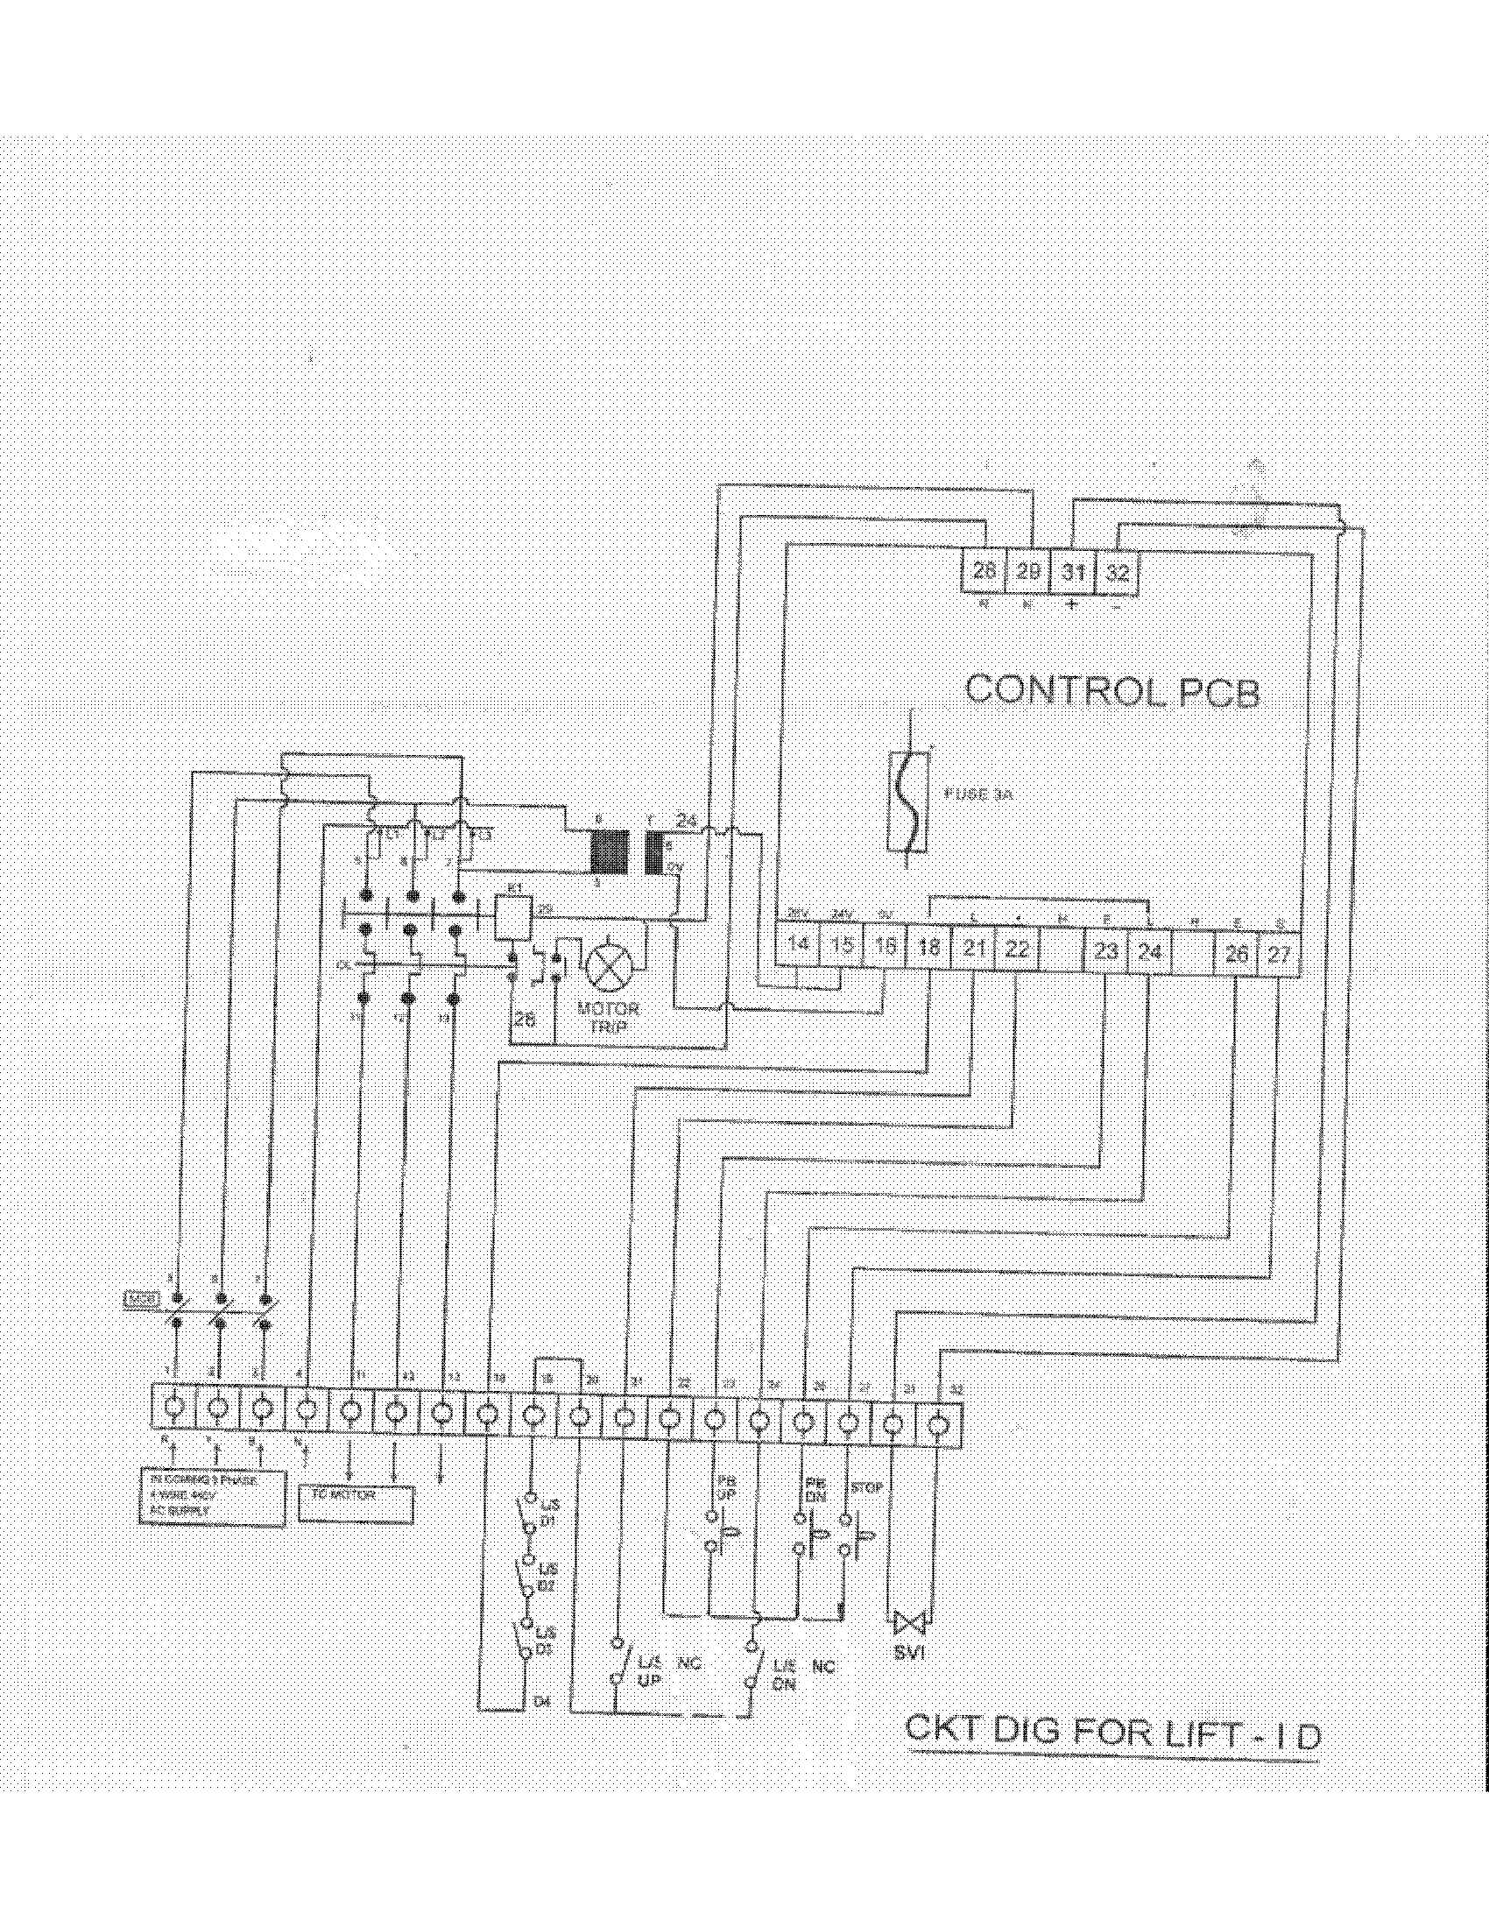

4.4 Certificates and References
The following certificates are attached in annexure at the end of this manual for the future reference of the buyer;
- GA Drawing
- List of scissor parts
- Hydraulic Circuit Diagram
- Hydraulic Part list
- Electrical Circuit Diagram
- Warranty Certificate

4.5 Warranty Clause
We certify that product(s) mentioned and supply as above meets our standard design and specification shown in our catalogue(s) and/or quotation(s) and/or specification sheet(s) unless otherwise specifically agreed by us. We warrant that the product(s) is free from defects in workmanship and material. This warranty does not cover damage resulting out of incorrect use or improper handling. We are not liable for consequential damages. Further Electrical, Electronics spares are also not covered under our standard warranty.

*****#####*****

